Extra Practice Problems (2.2 – 2.6)

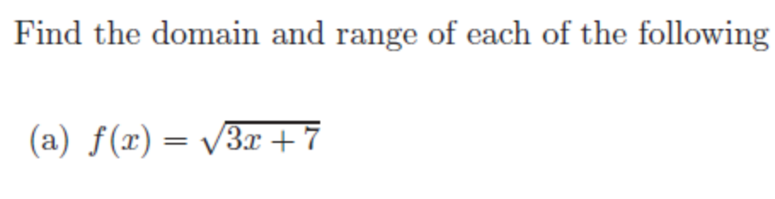
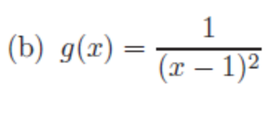

3.
Find a formula for the following graph:

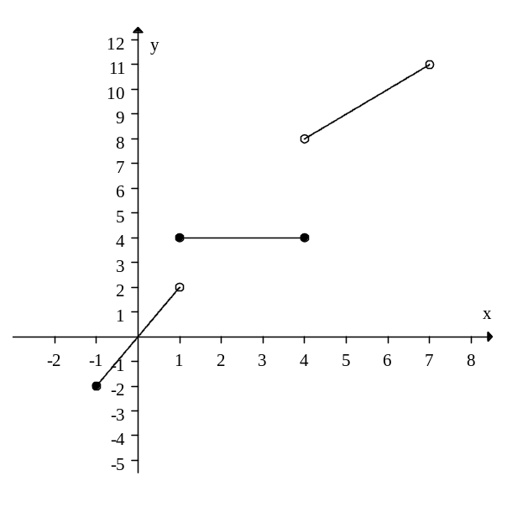

4. Let G(t) equal the amount of gas, in gallons, in your car during a road trip t hours after you start out. You start with 20 gallons and drive for 3 hours, leaving you with 14 gallons in the tank. You stop for lunch for an hour and then drive for 4 more hours, leaving you with 6 gallons. Construct a piecewise linear function for G(t).

5. Find the inverse function.

6. Let P=f(t) be the population, in millions, of a country at time t in years and let E = g(P) be the daily electricity consumption, in megawatts, when the population is P. Give the meaning and units of the function. Assume both f and g are invertible.

( a ) g(f(t))

( b )

7. The radius, r, in centimeters, of a melting snowball is given by r = 50 – 2.5t, where t is time in hours. The snowball is spherical, with volume . Find a formula for V = f(t), the volume of the snowball as a function of time

